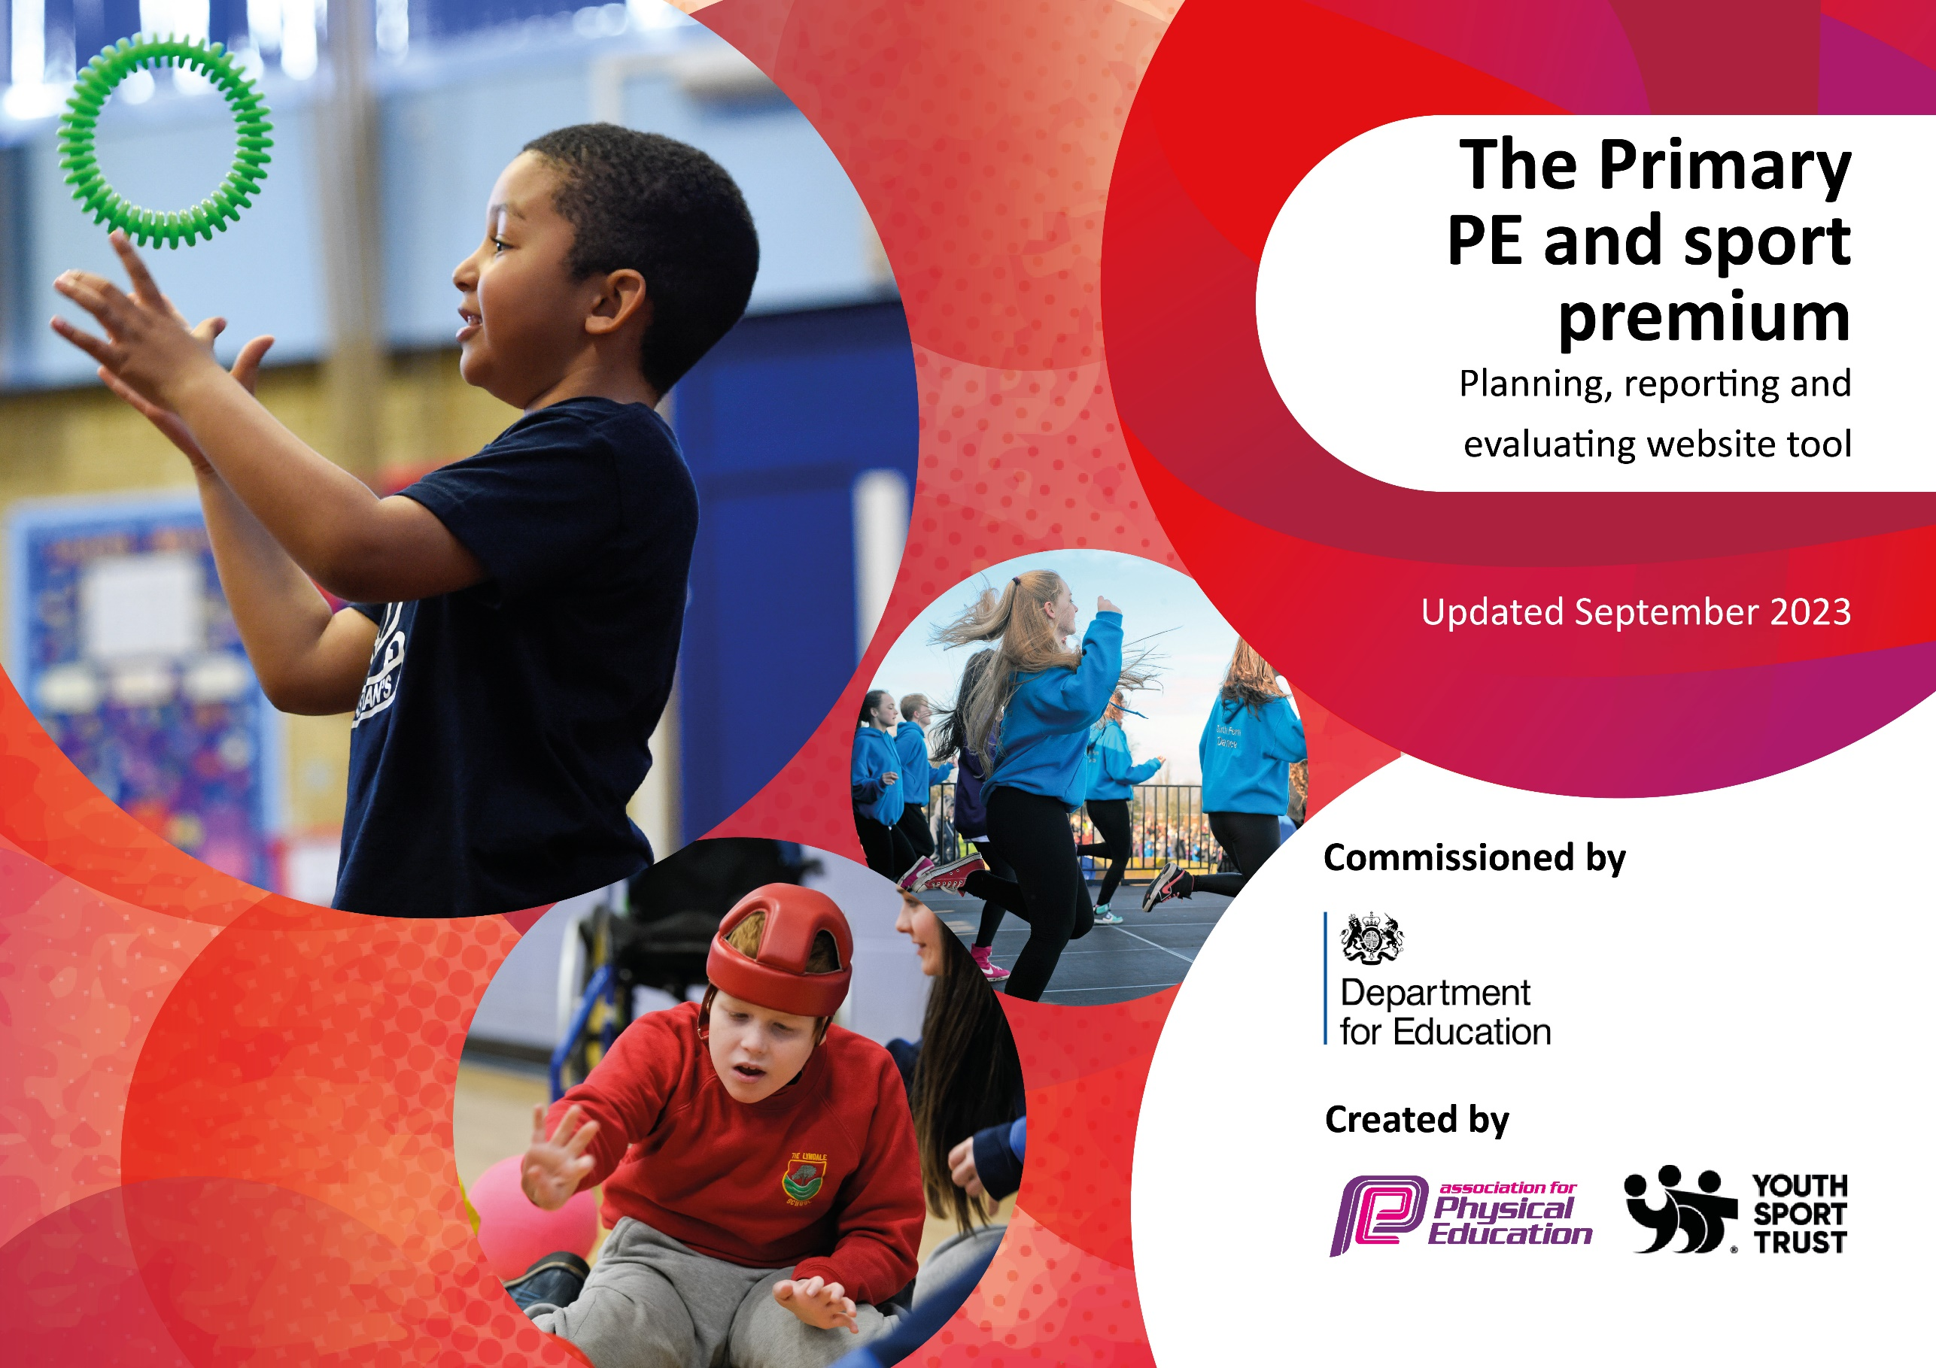

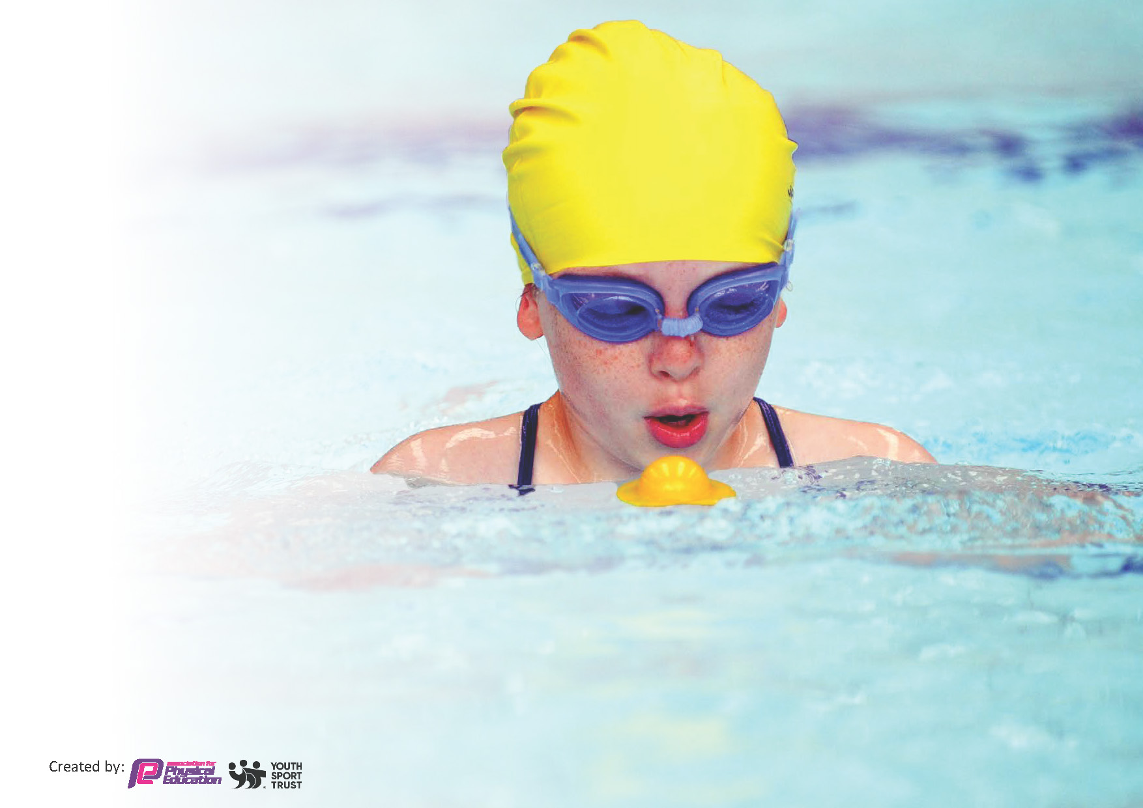
This template can be used for multiple purposes:
by:
- It enables schools to effectively plan their use of the Primary PE and sport premium
- It helps schools to meet the requirements (as set out in guidance) to publish information on their Primary PE and sport premium
- It will be an effective document to support Ofsted inspections enabling schools to evidence progress in Physical Education (PE) and evidence swimming attainment, which forms part of the PE National Curriculum. We would recommend schools consider
the Intent, Implementation and Impact of any spend, as examined within the Education Inspection Framework.

It is important that your grant is used effectively and based on school need.

Schools must use the funding to make additional and sustainable
improvements to the quality of the PE, School Sport and Physical Activity (PESSPA)
they offer. This means that you should use the Primary PE and sport premium to:

- Build capacity and capability within the school to ensure that improvements made now will benefit pupils joining the school in future years
- Develop or add to the PESSPA activities that your school already offers.

The Primary PE and sport premium should not be used to fund capital spend projects; the school’s core budget should fund these. Further detail on capital expenditure can be found in the updated Primary PE and sport premium guidance.

The Primary PE and sport premium guidance, outlines 5 key priorities that funding should be used towards. It is not

necessary that spending has to meet all the key priorities, you should select the priorities that you aim to use any funding towards.

Although completing this template is not a requirement for schools, schools are required to publish details of how they spend this funding. Schools must also outline what the impact this funding has had on pupils’ PE and sport participation and attainment and how any spending will be sustainable in the future. All funding must be spent by 31st July 2024.

The Department for Education has worked closely with the Association for Physical Education (afPE) and the Youth Sport Trust (YST) to develop this template and encourages schools to use it. This template is an effective way of meeting the reporting requirements of the Primary PE and sport premium.
Review of last year’s spend and key achievements (2022/2023)

We recommend you start by reflecting on the impact of current provision and reviewing your previous spend.

Activity/Action | Impact | Comments
All pupils take part in the daily mile initiative and school have the certificates and cards for this.  New playground markings  PE equipment purchased  Forest School sessions  PE leader given PE leadership time (30 mins every week included on top of PPA) and additional leadership time during busy periods.  PE storage facilities improved.  PE coach (Rugby Tots) – teachers have been in the sessions.  Gymnastics coach – teachers have been in sessions  PE Scheme purchased last year and continued use this year: Get Set 4 PE  PE lead completed PE leadership training  Judo sessions as an after-school club  Rugby Coach  Gymnastics coach  Residential cost subsidised to allow for all children to be able to attend.  Maypole used this year to allow for a greater experience of different types of dance, especially linked to British culture.  Whole School trip to Chill Factore  Waterwise sessions for year 5 and 6  Ulverston Dance Platform  All cluster schools pay towards the CPS events coordinator to allow tournaments to go ahead.  Rugby coach  Gymnastics coach  Children encouraged to enter cross country.  Children encouraged to enter cluster tournaments.  Additional staffing costs to facilitate tournaments and Peninsula games.  Travel costs to allow us to attend tournaments  Minibus training so that we can transport to events | Children receiving Daily Mile certificates – even some of the youngest children achieving 100 miles. Children motivated by new medal.  All children are active during the Daily Mile at their own pace.  New markings encourage active play.  New PE equipment ensures safety and allows all to take part in a range of sports  Forest School sessions allow pupils to develop new outdoor skills, be active and develop wellbeing through skills like confidence, resilience and teamwork.  Profile is raised through consistent leadership time.  PE equipment is properly stored and easily accessible.  Staff taking part in rugby sessions allowed them to develop their skills, knowledge and confidence to teach it themselves in future.  PE Scheme purchased last year and implemented fully this year. Provides staff with support for planning and clear progression of skills.  Training has increased knowledge, skills and confidence.  Pupils benefitted from the rugby sessions as well as staff.  From the implementations, we have found that many children have developed new passions e.g.:  Children have taken part in activities, first experienced in school, outside of school such as entering judo competitions.  A large group of children now do Judo weekly and discovered this passion through our taster sessions.  Skills deepened in rugby.  Skills developed in skiing/rock climbing through our trip to Chill Factore. Pupil enjoyment and engagement raised.  Children have experienced a broad range of sports.  Children in year 5 and 6 have extended their swimming skills by learning open water skills at Waterwise.  All children in KS2 have taken part in cluster tournaments.  Children enjoy competitive sports.  All children in school have taken part in competitive sports this year.  Without additional staffing, tournaments would not have been able to go ahead. This staffing means that we have been able to take part in nearly all tournaments this year. | Children continue to use the Daily Mile track – need to raise profile again for 24-25, purchase further certificates/medals  Children continue to use playground markings.  PE equipment has been well used this year.  Forest School was very enjoyable. Need to find new provider for 24-25, and offer to all children.  PE leadership time has again been provided this year, along with additional time for organizing whole-school events (eg: Sports Day, Tree Top Trek trip)  been well maintained this year  continued this year with Rugby Tots and Cricket.  Staff continue to Use Get Set 4 PE and find it a useful resource  Clubs continue to be offered, by outside coaches as well as our own staff  Judo club continues to grow with some Nursery children joining recently  Whole school trip was very popular, governors encouraged another this year – tree top trek at Brockhole was chosen  Waterwise was continued this year  Continued to take part in as many cluster sessions as possible this year, KS1 have also attended events at CPS.

Key priorities and Planning
This planning template will allow schools to accurately plan their spending.

Action – what are you planning to do | Who does this action impact? | Key indicator to meet | Impacts and how sustainability will be achieved? | Cost linked to the action
Forest Schools for Y1/2 and Y5/6  Visit from US Basketball player  Football coaching  Rugbytots  Orienteering  Tree top Trek (whole school)  R, Y1/2 Castle Head  Cricket coaching  Waterwise  Dance Platform  Movement in the classroom (wobble stools, standing desks, resistance bands)  Storage for PE equipment | Lunchtime supervisors / teaching staff, coaches - as they need to lead the activity  pupils – as they will take part. | Key indicator 2 -The engagement of all pupils in regular physical activity – the Chief Medical Officer guidelines recommend that all children and young people aged 5 to 18 engage in at least 60 minutes of physical activity per day, of which 30 minutes should be in school.  Key indicator 4: Broader experience of a range of sports and activities offered to all pupils. | More pupils meeting their daily physical activity goal, more pupils encouraged to take part in PE and Sport Activities. | 1680.00  300.00  250.00  600.00  58.64  320.00  7.00  646.92  440.00  165.88 staff costs  89.00 staff costs  436.67  525.00  600.00  166.35  185.00  315.33  796.00  597.00  2500 (TBC)

Rugbytots  Cricket coaching  Football coaching  PE leadership time (30 mins per week)  CPS PE Co-ordinator group  INSET Key Steps Gymnastics  Waterwise  Swimming  Additional spending:  repairs to PE equipment following sports inspection,  Surplus costs for residentials  Transport costs to sporting/outdoor ed events  PE kit/equipment (netball bibs, spare kit) | Primary generalist teachers. | Key Indicator 1: Increased confidence, knowledge, and skills of all staff in teaching PE and sport.  Key indicator 5: Increased participation in competitive sport. | Primary teachers more confident to deliver effective PE supporting pupils to undertake extra activities inside and outside of school, including teaching water safety and swimming and as a result improved % of pupil’s attainment in PE. | already mentioned above  894.63  885.00  77.00  already mentioned above  from school budget  661.40  104.00  628.00  1750.00  1336.41  9.00  119.98  24.00  29.98

Key achievements 2023-2024
This template will be completed at the end of the academic year and will showcase the key achievements schools have made with their Primary PE and sport premium spending.

Activity/Action | Impact | Comments
Providing additional opportunities for physical activity:  Football, Rugby and Cricket coaching  Cartmel Cluster sports tournaments  Supporting outdoor education for all our pupils – forest schools, residentials, day outings  Supporting movement and wellbeing in the classroom | Staff taking part in coaching sessions allowed them to develop their skills, knowledge and confidence to teach it themselves in future. Children have had opportunities to learn more about these sports and learn about club opportunities beyond school.  Competing with other schools in the cluster encourages children to develop their approach to team games, good sportsmanship and a competitive edge  Providing opportunities for children that involve exploring outdoor and adventurous activities that cannot be catered for in school, and that children may not experience otherwise  Many of our children require the opportunity for movement breaks, and to be able to move around within the learning space | Explore and arrange coaching for different sports next year  Need to source a new forest school provider for next year – whole school  Whole school activities – research new ideas  Residentials will switch next year for a cultural focus (aiming for 2 year cycle, alternating between OAA and city visit)  These purchases will continue to be used for the children moving up through school

Swimming Data
Meeting National Curriculum requirements for swimming and water safety.
Priority should always be given to ensuring that pupils can perform safe self-rescue even if they do not fully meet the first two requirements of the National Curriculum programme of study

Question | Stats: | Further context  Relative to local challenges
What percentage of your current Year 6 cohort can swim competently, confidently and proficiently over a distance of at least 25 metres? | 88% | Only one pupil who has not achieved the level. Lack of confidence due to difficulties with vision
What percentage of your current Year 6 cohort can use a range of strokes effectively [for example, front crawl, backstroke, and breaststroke]? | 88% | All except one pupil were able to demonstrate a range of swimming strokes

What percentage of your current Year 6 cohort are able to perform safe self-rescue in different water-based situations? | 77% | We took part in 3 Waterwise sessions at the lake. Children were taught a variety of methods for self-rescue – not all were confident in carrying out, but know what they should do
If your schools swimming data is below national expectation, you can choose to use the Primary PE and sport premium to provide additional top-up sessions for those pupils that did not meet National Curriculum  requirements after the completion of core lessons. Have you done this? | No
Have you provided CPD to improve the knowledge and confidence of staff to be able to teach swimming and water safety? | No | Our swimming is taught by coaches at the Leisure Centre and our Waterwise course is delivered by an external coach.

Signed off by:

Head Teacher: | Mandy Barnsley
Subject Leader or the individual responsible for the Primary PE and sport premium: | Sam Barker, PE Subject Leader
Governor: | Sara McClure
Date: | 19.7.2024

